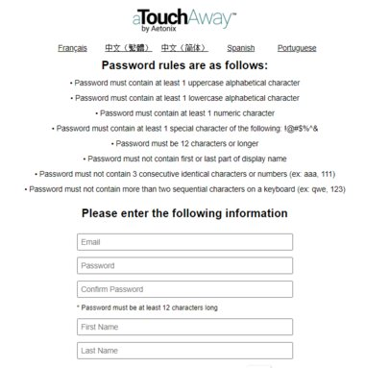

**Another way to invite a family member to join aTouchAway is to invite them within the app; this requires you to know their email address.**

1. Navigate to your patient; click your patient, click on contacts
2. Click on invite new contact
3. Enter the family member’s email address. This step generates an invitation to the recipient to download the aTouchAway app.
4. The family member receives an invitation email from Aetonix aTouchAway containing a link. When clicked they are taken to a registration page
5. Note that the family member must sign in using the same email they provided to the clinical team
6. Once registered, the family member receives instructions to download aTouchAway.
7. When downloaded, the family member signs in to aTouchAway which generates a contact request on the clinician tablet.
8. Tap accept.
9. The family member is now added as a contact.

### **Alternative method for inviting a family member to join aTouchAway**