Multiple Long-Term Conditions Challenge Fund
Guy’s & St Thomas’ Charity is an independent, place-based foundation. It works with Guy’s and St Thomas’ NHS Foundation Trust and others to improve the health of people living in the London boroughs of Lambeth and Southwark.
The Charity takes a programmatic approach, tackling complex health issues for people in Lambeth and Southwark, understanding what's underneath these issues, and working with others to address them. It aims to share insights with others tackling similar issues in urban areas.
The charity aims to support research from across its partner network to examine and develop innovations, or explore new initiatives, which may help to better understand some of the complex challenges facing local communities. One of these health challenges is multiple long-term conditions – and how we might slow down the journey from one to many long-term conditions.

Background
The Department of Health defines a long-term condition as “a condition that cannot, at present, be cured but is controlled by medication and/or other treatment/therapies”. Long-term conditions are a key focus of the NHS, as people with long-term conditions tend to be heavy users of both primary and secondary care. People with long-term conditions account for 50% of all GP appointments, 64% of all hospital outpatient appointments and 70% of the total spend on health & social care.

Recent research, funded by Guy’s and St Thomas’ Charity, has explored people’s progression from one to many long-term conditions in an urban environment and highlighted some key observations:
- Although multiple long-term conditions are frequently seen in older age and linked to frailty, this is not just a problem of old age. In Lambeth & Southwark, more than a third of the people with multiple long-term conditions are of working age.
- People’s progression from one condition to many varies significantly, influenced by mix of health and social factors – including income, ethnicity and social context (e.g. housing, employment, relationships).
- People experience MLTCs as moments of complexity, focusing on individual diseases underplays the cumulative impact on individual health and wellbeing and the wider impact on individual’s lives
These observations have a particular relevance for Lambeth & Southwark, where nearly a fifth of all residents have at least one long-term condition. Half of local residents are under 35 and just under half come from black, Asian and other minority ethnic (BAME) backgrounds. Furthermore, there are high levels of income inequality across the two boroughs. The research funded by Guy’s and St Thomas’ Charity also identified that although black communities make up 18% of the local adult population, they account for 27% of people with multiple long-term conditions. Furthermore, those living in the most deprived areas are developing conditions on average 10 years earlier than those living in the least deprived areas.

The Challenge
Research into why particular people develop multiple long-term conditions and the rate of progression from a single long-term conditions to multiple long-term conditions is at a relatively early stage. Furthermore, much of the research which has been performed has studied older populations, far less data collection and analysis has been conducted on adults of working age.
A number of key gaps in current knowledge have been identified recently by the Academy of Medical Sciences, and the gaps which have relevance for this funding call include:
- What are the common trends in those who develop multiple long-term conditions and how do these change over a period of time?
- What factors (including behavioural, environmental, sociodemographic and biological) contribute to the development of the most common combinations of long-term conditions?
- How can intervening earlier help prevent the progression from a single long-term condition to multiple, or reduce the rate of progression?
Previous studies investigating the determinants of multiple long-term conditions have produced inconclusive findings and have been largely limited to cross sectional studies. Longitudinal studies of the causative factors of the most common disease clusters and combinations found in multiple long-term conditions, would facilitate a better understanding of the trends associated with the rate of progression.
Health, social and community factors are all thought to have a bearing on the rate of progression. Socioeconomic deprivation has been shown to be a factor in influencing the development of multiple long-term conditions across a range of age groups in adulthood. Additionally, the same study highlighted that the most common multimorbidity of those under 55 combined both physical and mental long-term conditions.
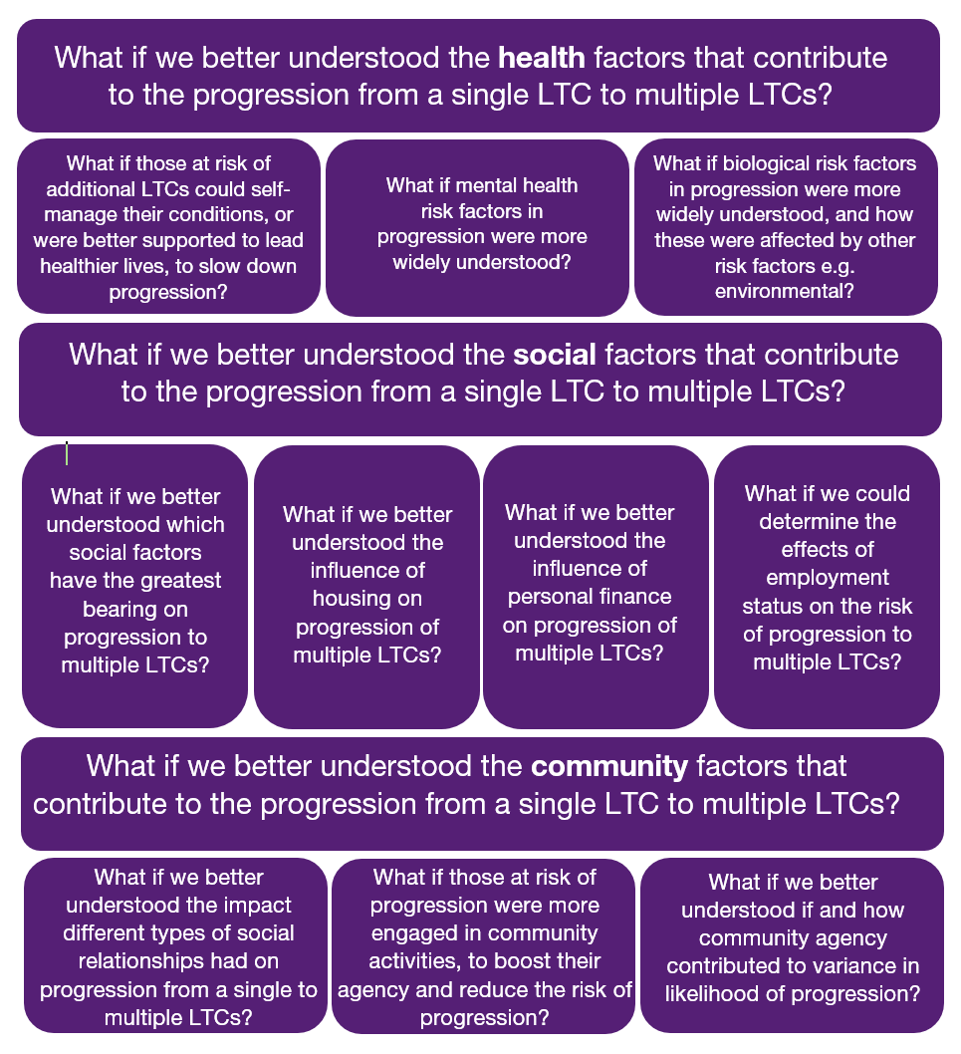
The “What If” statements below are some illustrations of scenarios that have the potential to help meet unmet need in this challenge area. The statements are intended as examples only.

The Scope
The primary focus of this call is to examine the progression from one long-term condition to a second or third long-term condition, in working age adults in Lambeth and Southwark, and how this progression could be slowed down or halted. We are particularly interested in people from lower income or Black, Asian and Minority Ethnic communities.
Research with populations outside of Lambeth and Southwark will be considered if the knowledge generated can be related back or compared to these local populations.
Diagnosis or management of individual long-term conditions is out of scope unless they are explicitly examining how this could slow down progression to multiple long-term conditions.
We are looking for applications from across the medical and social sciences. The scope of the call includes, but is not limited to:
- Primary data collection
- Analysis of routinely collected data
- Action research or applied research projects

Eligibility
The principal investigator must be an employee of a partner organisation of King’s Health Partners (King’s College London; King’s College Hospital NHS Foundation Trust; South London and Maudsley NHS Foundation Trust; and Guy’s and St Thomas’ NHS Foundation Trust).
The Multiple Long-Term Conditions Challenge Fund encourages collaboration with partners outside of KHP, where this provides value to the research. Whilst the fund seeks impact on a local level, we encourage applicants to think about how the research can have impact beyond KHP and our local communities. Applications must be led by a researcher within KHP but can collaborate more widely. For example, where additional relevant expertise and data is available externally, applications should consider including co-investigators or collaborators who can provide this. Funds can be used to cover the directly incurred costs of such collaborators where necessary and should be included in the budget.
External researchers interested in collaborating in this scheme should contact the relevant researchers within KHP. For those who do not have a collaborator within KHP but are interested in making contact, please contact khpresearchoffice@kcl.ac.uk with a description of your research interests, CV and expertise/ access to patients/ data and any other resources which may be relevant. We will then pass your details on to relevant researchers within KHP who may wish to discuss the opportunity for collaboration.

Funding Available
The Multiple Long-Term Conditions Challenge Fund will award projects of up to £125K for projects lasting up to 18 months. The fund aims to grant 8-10 awards in total, split over two rounds.

Key Dates
Round | Call opens | Submission Deadline | Panel Meeting | Projects start by | Mid-point learning event | Maximum Project Duration
1 | 1st November 2018 | 21st January 2019 | 4th April 2019 | 1st July 2019 | 2nd April 2020 | 18 months
2 | April 2019 | 1st July 2019 | 24th September 2019 | 31st December 2019 | 1st Sept 2020 | 18 months

DH, Long Term Conditions Compendium of Information Third Edition, 2012. https://assets.publishing.service.gov.uk/government/uploads/system/uploads/attachment_data/file/216528/dh_134486.pdf
NHS England, Enhancing the Quality of Life for People Living with Long Term Conditions, 2014. https://www.england.nhs.uk/wp-content/uploads/2014/09/ltc-infographic.pdf
Guy’s & St Thomas’ Charity, From one to many - Exploring people’s progression to multiple long-term conditions in an urban environment, 2018. https://www.gsttcharity.org.uk/sites/default/files/GSTTC_MLTC_Report_2018.pdf
Richmond Group of Charities, “Just one thing after another” Living with multiple conditions , 2018. https://richmondgroupofcharities.org.uk/sites/default/files/final_just_one_thing_after_another_report_-_singles.pdf
Guy’s & St Thomas’ Charity, From one to many - Exploring people’s progression to multiple long-term conditions in an urban environment, 2018. https://www.gsttcharity.org.uk/sites/default/files/GSTTC_MLTC_Report_2018.pdf
The Academy of Medical Sciences, Multimorbidity: a priority for global health research, April 2018, https://acmedsci.ac.uk/file-download/82222577
The Academy of Medical Sciences, Multimorbidity: a priority for global health research, April 2018, https://acmedsci.ac.uk/file-download/82222577
McLean G et al., The influence of socioeconomic deprivation on multimorbidity at different ages: a cross-sectional study. Br J Gen Pract 2014; 64 (624): e440-e447. DOI: https://doi.org/10.3399/bjgp14X680545

