Multiple Long-Term Conditions Challenge Fund

Introduction
Guy’s and St Thomas’ Charity is an independent, place-based foundation focussed on the ways in which cities shape our health.
The Charity takes a very applied approach to tackling health inequalities and address complex urban health issues like childhood obesity, long term conditions, air pollution and adolescent mental health. To do this, it works with a multitude of partners, including Guy’s and St Thomas’ NHS Foundation Trust and others to improve the health of people living in the London boroughs of Lambeth and Southwark. It aims to share insights with others tackling similar issues in urban areas.
The charity supports research from across its partner network to examine and develop innovations, or explore new initiatives, which may help to better understand some of the complex challenges facing local communities. The interventions tend to target change at a systems level, changing the urban environments in which people experience health. The wider determinants of health are central to this strategy.

The Charity has a large programme focused on multiple long-term conditions – specifically how we might slow down the journey from one to many long-term conditions. The Charity is looking for researchers who can help to develop our understanding of how and why people progress from one to many long-term conditions, including risk and protective factors and what interventions might help to slow or reduce this progression. More about this programme is available here.

The Charity feels that researchers from across the academic spectrum could conduct research which helps to develop this understanding and would welcome applications from different disciplines, including, but not limited to sociologists, political scientists, epidemiologists, human geographers and others.

Background

Long-term conditions are health conditions for which there is currently no cure, but which can be managed with drugs and other treatments. Recent research, funded by the Multiple Long-Term Conditions Programme at Guy’s and St Thomas’ Charity, has explored people’s progression from one to many long-term conditions in an urban environment and some key findings are:
- Although multiple long-term conditions are seen in older age and linked to frailty, this is not just a problem of old age. In Lambeth & Southwark people are developing their first condition in their 30s and, if they progress to a second condition, this happens in their 40s. Large numbers of people with multiple long-term conditions are of working age.
- People experience MLTCs in complex ways. Focusing on individual diseases underplays the cumulative impact on individual health and wellbeing and the wider impact on individual’s lives.
- People’s progression from one condition to many varies significantly, influenced by mix of health and social factors – including income, ethnicity and social context.
Importantly, the research highlights inequalities amongst our population and the significance of the wider determinants of health (for example housing, employment, financial circumstances) on the progression of long-term conditions, for example:
- Black communities make up 18% of the local adult population, but they account for 27% of people with multiple long-term conditions.
- Those living in the most deprived areas in Lambeth and Southwark are developing conditions on average 10 years earlier than those living in the least deprived areas.

The challenge

What drives progression?

Research into the Charity’s areas of interest in terms of multiple long-term conditions is limited.

Previous studies investigating the determinants of multiple long-term conditions have produced inconclusive findings and have been largely limited to cross sectional studies. In healthcare, there has been a lack of longitudinal studies to help us understand the most common disease clusters, causative factors and rate and nature of progression. To address this, the Charity has funded a large research project being led by Dr Mark Ashworth at KCL, which is examining the prevalence and pattern of long-term conditions amongst people registered in primary care data over a 10-year period.
This study will greatly help us to understand the ‘what’, and to an extent, the ‘when’ and ‘who’ in terms of the picture of multimorbidity in Lambeth and Southwark. However, it will be limited in developing a deep understanding of the very important questions of ‘how’ and ‘why’ people progress to multimorbidity.
Below is Dahlgren and Whitehead’s model of the main determinants of health. There are gaps in the evidence base in terms of all of these contributing factors, however in terms of the Charity’s role and position in the system, it believes it can add the most value, and will be most likely to influence, factors in the outer two bands of this model;
1. Living and working conditions, and
2. General socio-economic, cultural and environmental conditions.
Research which helps to develop a deeper understanding of the influence and experience of these factors would be particularly helpful (see further detail below in ‘Scope’).
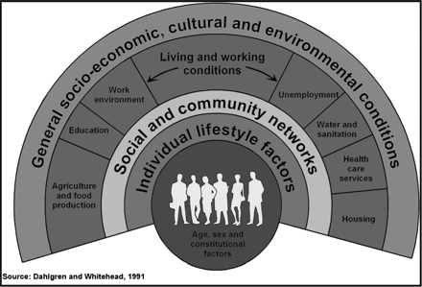
As noted, the KCL research project will give us much more understanding of what multimorbidity people experience in Lambeth and Southwark, as well as who experiences this (what groups of people) and the timings of when they progress. Saying that, the study (and other studies like it in the evidence base) has limitations in that it is a secondary analysis of primary care data, so therefore reliant on the quality and nature of recording, as well as people being identified in primary care.
The Charity, along with other researchers, hypothesises that some conditions are likely to be under-represented in primary care, thereby underestimating the true prevalence of multimorbidity. There is opportunity for further research to get further underneath this. For example, it is known that there is stigma associated with mental health conditions and this can impact more strongly on particular groups. What impact does this have on people self-identifying as having a condition and/or being willing/able to access support?

What are effective interventions?
The next step from understanding the development of multimorbidity is of course the question of how we can effectively intervene to prevent or slow progression from a single long-term condition to multiple conditions.
There is currently little evidence about what interventions could help to slow down the trajectory to multiple long-term conditions, including those that address the social determinants of health and/or relate to health inequalities. There is real need to develop the evidence base around how we might influence people’s health outcomes through intervening in areas like finance, employment and housing (see further detail below).
Finally, it should be noted, that in respect of both evidence related to progression and interventions, very little research is focused on adults of working age (as opposed to older populations), although our data suggests this is the period in people’s lives when they progress from one condition to more.

The Scope
The focus of this call is for preventative efforts to slow progression for working age adults, who live with one health conditions and are at risk of developing many. This requires to:
- examine how circumstances and environments (employment, finances, housing) impact the progression from one long-term condition to a second or third long-term condition, in working age adults in Lambeth and Southwark
- understand how this progression could be slowed down or halted through interventions.

Working with experts, the Charity has developed the following programme focus on 32 long-term conditions and 6 risk factors.

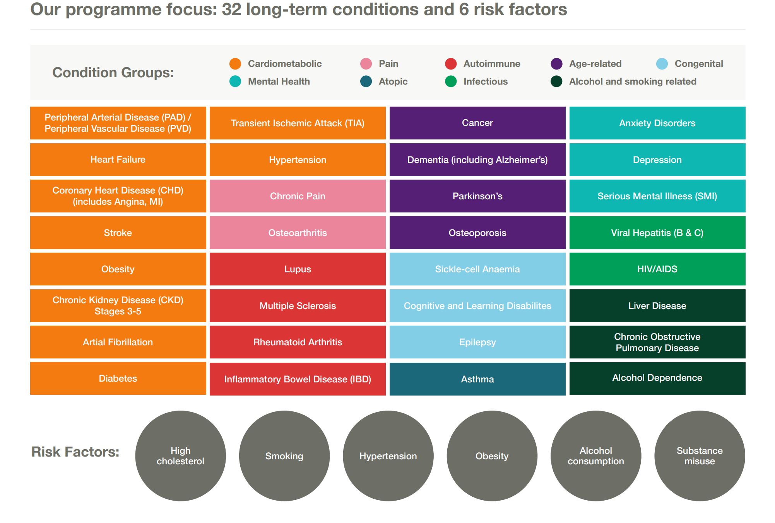

The call is not focused on people over the age of 65 or people who are at the end of their lives. It is also not focused on children or adolescents (as we know people in Lambeth and Southwark on average develop their first long-term condition in their 30s and their second, if they develop one, in their 40s).
Given the issues around inequality, described above, we are particularly interested in studies, which focus on people from lower income and/or Black, Asian and Minority Ethnic communities. The Charity would also encourage researchers to consider intersectionality and how specific groups may have specific experiences and face particular disadvantage.
Research within Lambeth and Southwark would be preferred, however research with populations outside of Lambeth and Southwark will be considered if the knowledge generated can be related back or compared to these local populations (for example in similarly urban areas).
Diagnosis or management of individual long-term conditions is out of scope unless they are explicitly examining (a) how this could slow down progression to multiple long-term conditions, or (b) the interrelationship between that long-term condition and people’s circumstances and risk of developing another long-term condition.
We are looking for applications from across social sciences and medical sciences.
The scope of the call includes, but is not limited to:
- Research which helps us to understand in greater depth people’s experiences of multi-morbidity, including the influence of the social determinants of health and health inequalities – e.g. primary data collection, action research/applied research, ethnography and other types of qualitative research
- Research which provides evidence about which interventions are effective (in terms of improving health outcomes) and for whom – e.g. Evaluative studies of interventions, Feasibility or Pilot studies
- Research which gives us more insight into the progression of conditions – e.g. epidemiological studies, data linkage and analysis

Particular areas of focus and interest for the Charity
As our programme has matured, through working with local partners and people living in our place, we have developed several areas of interest. Our programme is evolving as we learn, so this list is not exhaustive, however we would be interested in any research submissions which explore the following:

Wider determinants of health
Employment | Employer health and wellbeing offers  Flexible working, including the gig economy  In work retraining  Supporting people with LTCs into work  Addressing people with LTCs employment needs in primary care
Housing | Security of housing  Experiences of control/agency in housing circumstances
Financial circumstances | Exploring preventative approaches: pre-crisis, supporting long term behaviour change  Cashflow management  Engaging new environment owners outside primary financial health system (e.g. workplace, charities)  Welfare benefits & legal issues

Healthcare | Improved early clinical care (including integration)  Improved self-managed care  Reduce exposure to clinical and social risks  Focus on Diabetes and Chronic Pain as gateway conditions

Eligibility
The principal investigator must be an employee of a partner organisation of King’s Health Partners (King’s College London; King’s College Hospital NHS Foundation Trust; South London and Maudsley NHS Foundation Trust; and Guy’s and St Thomas’ NHS Foundation Trust).
The Multiple Long-Term Conditions Challenge Fund encourages collaboration with partners outside of KHP, where this provides value to the research. We strongly encourage partnerships with practitioners in our place who seek impact in our local communities. Applications must be led by a researcher within KHP but can collaborate more widely. For example, where additional relevant expertise and data is available externally, applications should consider including co-investigators or collaborators who can provide this. Funds can be used to cover the directly incurred costs of such collaborators where necessary and should be included in the budget.
External researchers interested in collaborating in this scheme should contact the relevant researchers within KHP. For those who do not have a collaborator within KHP but are interested in making contact, please contact khpresearchoffice@kcl.ac.uk with a description of your research interests, CV and expertise/ access to patients/ data and any other resources which may be relevant. We will then pass your details on to relevant researchers within KHP who may wish to discuss the opportunity for collaboration.

Funding Available
Call one and two have concluded with 7 projects funded (https://www.gsttcharity.org.uk/get-involved/news-and-opinion/news/seven-new-projects-explore-long-term-conditions-urban-places ) .
We are pleased to launch a third call for projects. For round 3 we have £700K available to award. Projects can be up to £175K with a maximum duration of 24 months. We welcome projects of smaller value or duration where appropriate.

Key Dates

Round | Call opens | Submission Deadline | Panel Meeting | Projects start by | Mid-point learning event* | Maximum Project Duration
3 | March 2020 | 5pm on 11th May 2020 | July 2020 | Within 3-6 months of outcome | Nov 2021 | 24 months

Guy’s & St Thomas’ Charity, From one to many - Exploring people’s progression to multiple long-term conditions in an urban environment, 2018. https://www.gsttcharity.org.uk/sites/default/files/GSTTC_MLTC_Report_2018.pdf
Richmond Group of Charities, “Just one thing after another” Living with multiple conditions , 2018. https://richmondgroupofcharities.org.uk/sites/default/files/final_just_one_thing_after_another_report_-_singles.pdf
The Academy of Medical Sciences, Multimorbidity: a priority for global health research, April 2018, https://acmedsci.ac.uk/file-download/82222577
Dahlgren, G & Whitehead, M (1991)“What Can Be Done About Inequalities in Health?”

