Guidance for staff on how to download a completed ICU diary from aTouchAway to PDF format
- Login to the Aetonix dashboard via the internet with this URL: https://dashboards.aetonix.com/. Bookmark this link. Aetonix works best using Google Chrome.

- Use the same login name and password for the Aetonix dashboard as used for the ICU diary aTouchAway account e.g. icudiarystaff@xxxx.icu and xxxx&family1

Make sure this is set to the United Kingdom region. Only staff should log into the dashboard. This is not accessible to family members.

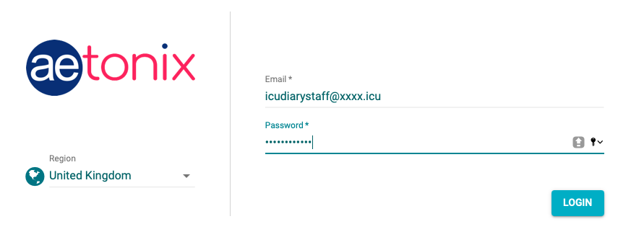

- On the Dashboards homepage, click onto the word ‘creation/token’ under ‘User Management’ section.

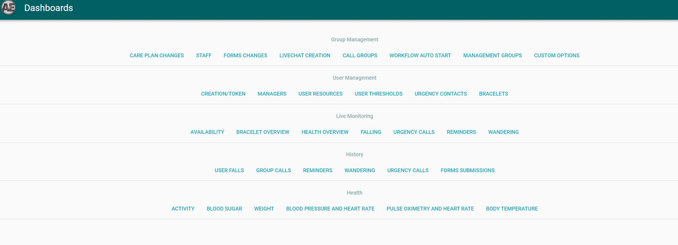

- In ‘User Creation/Token’, type the patient’s name in the search box and when it appears, click on ‘select’, to highlight the patient’s name
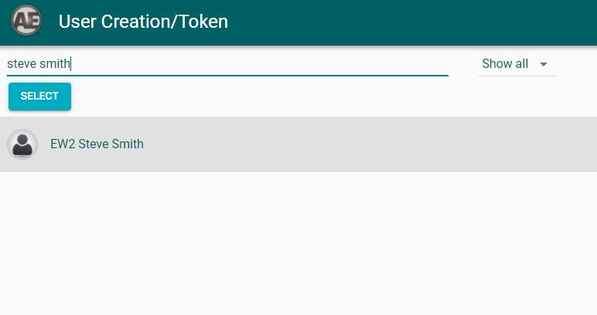

- On the right-hand side of the highlight tab, there are six different icons. Click on the ‘edit’ symbol to view the patient’s profile.

- On the ‘Edit User Info’ page, change the ‘user active state’ to ‘user is active’ and change ‘search privacy’ option to ‘visible in search’. Once these settings are changed, press the save button. This will change the settings to make a deactivated profile, active again and possible to retrieve the diary.

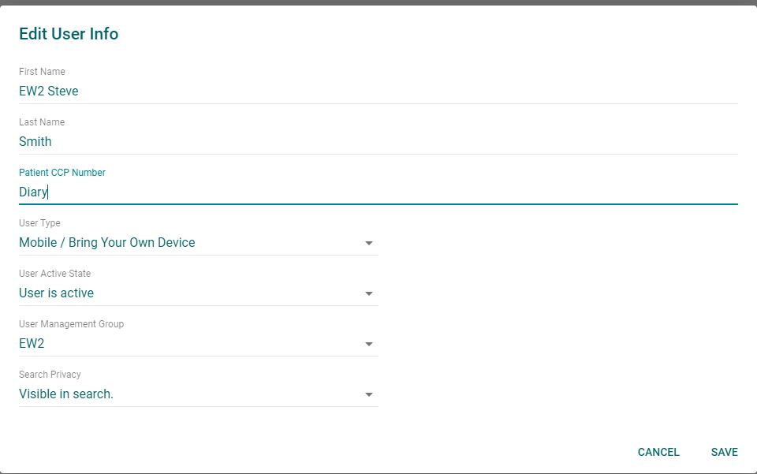

- Once this is done, go back onto the main dashboard by clicking on the three-line tab on the top right corner of the screen (circled in red). Look down the drop down menu to select ‘Dashboards’ to get back to the main Dashboards homepage.

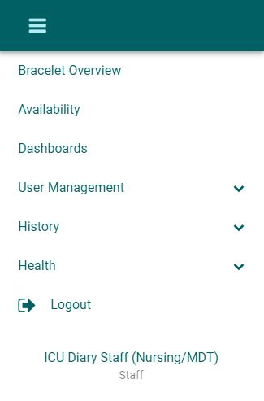

- From the Dashboard homepage, click on ‘Managers’ under the ‘User Management’ section.

- In the ‘Managers’ section, there are two columns, ‘Users’ and ‘Managers’ that are presented side by side. Type the patient’s name in the ’Search Name or Client Number’ box in the ‘Users’ section. When the patient’s name appears, select the name by highlighting the patient.

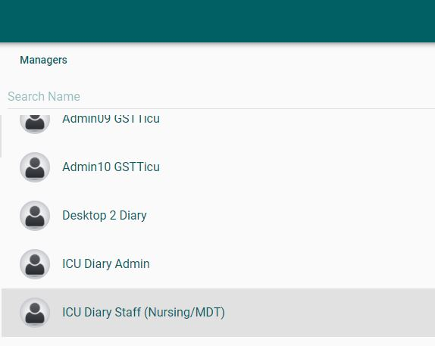
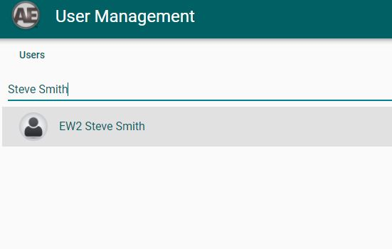
On the opposite ‘Managers’ column, a list of managers will appear, indicating how many managers this patient account has. A manager is anyone who can make an ICU diary entry. The login account ‘ICU Diary Staff (Nursing/MDT)’ should be visible as a manager. If the login account name ‘ICU Diary Staff (Nursing/MDT)’ is not visible in the list of managers, the login account must be added by following steps 9-12 below. If the login account ‘ICU Diary staff (Nursing / MDT)’ is visible, skip to step 14 below.

- Click on the blue ‘ADD’ toolbar on the bottom right-hand corner, underneath the ‘Managers’ column.

- Type in the login email address for example ‘icudiarystaff@xxxx.icu’ in the search box. This brings up the manager account name of ‘ICU Diary Staff (Nursing/MDT)’. Click on the account name to highlight it blue. Once this is done, close the search box.

- The generic account name ‘ICU Diary Staff (Nursing/MDT)’ is then automatically added to the patient’s ‘managers’ list, and it should be visible. Scroll down the list of account names on the manager’s column to ensure that the ‘ICU Diary Staff (Nursing/MDT) is listed as a manager.

- Once this is done, go back onto the main dashboard by clicking on the three-line tab on the top right corner of the screen (circled in red). Look down the drop down menu to select ‘Dashboards’ to get back to the main Dashboards homepage.

- On the Dashboards homepage, click onto the word ‘creation/token’ under ‘User Management’ section.

- In ‘User Creation/Token’, type the patient’s name in the search box and when it appears, click on ‘select’, to highlight the patient’s name.

- On the right-hand side of the highlight tab, there are six different icons. Click on the ‘eye’ symbol to view the patient’s profile.

- The patient’s profile will appear with multiple tabs beneath. Click on ‘Forms’ to reveal ‘My ICU Diary’ with the heart symbol.

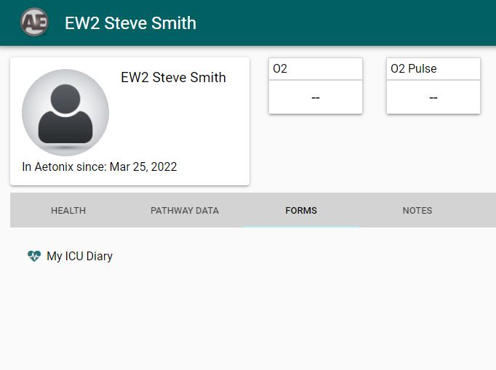

- The ICU diary can then be exported as a PDF. On the top right-hand corner of the screen, underneath the three lines, click the ‘Export PDF’ button to convert the ICU diary into PDF format.
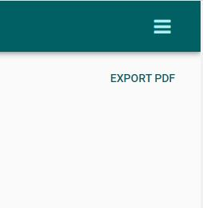

- A box will appear on the screen allowing export of the ICU diary into PDF format. Click the next button exactly four times to get to the required ‘Export PDF’ page to choose which documents to export.

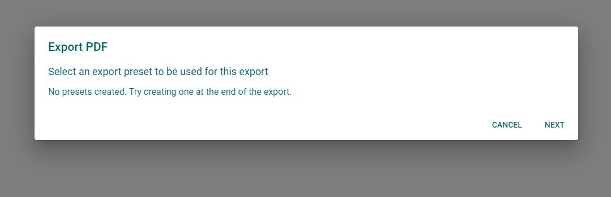

- Once the ‘Export PDF’ page is reached as shown below, tick the ‘My ICU Diary’ box and change the option on ‘Sort By’ button to ‘Oldest to Newest’ to ensure that the diary is saved in chronological order. Click ‘Next’, to save the document
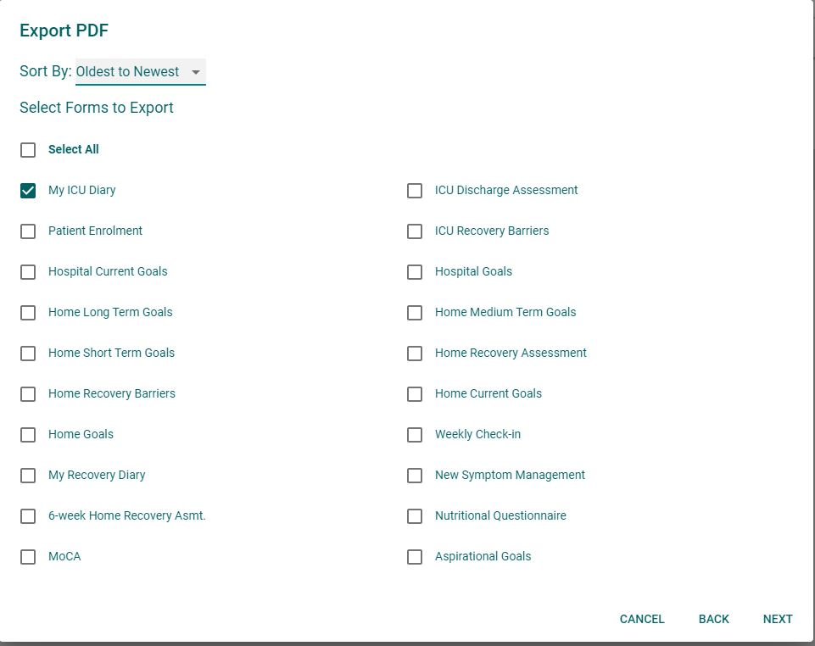

- Continue to press ‘next’ until the end of the options is reached and the ‘save’ button appears at the bottom of the ‘Export PDF’ page. Press ‘save’ to generate and download the PDF file.

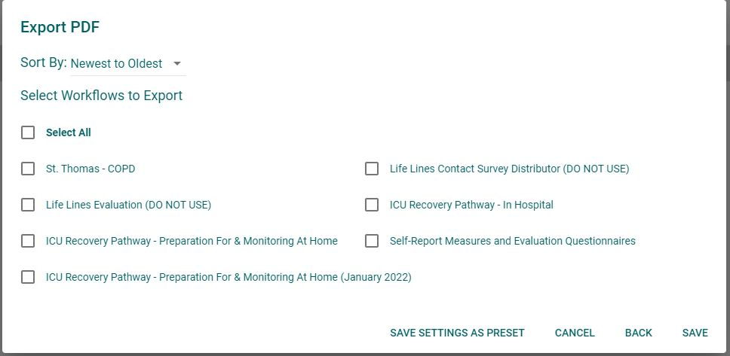

- A PDF file will be generated with the patient’s name and appear on the bottom screen of your device.

- Open the PDF document and check all the correct details are present. The PDF should appear as seen in picture below, named ‘Patient Summary Report’. It will contain all the contents of the ICU diary.

NOTE: This PDF document can be printed out or the PDF document attached in an email sent to the patient or the patient’s family.

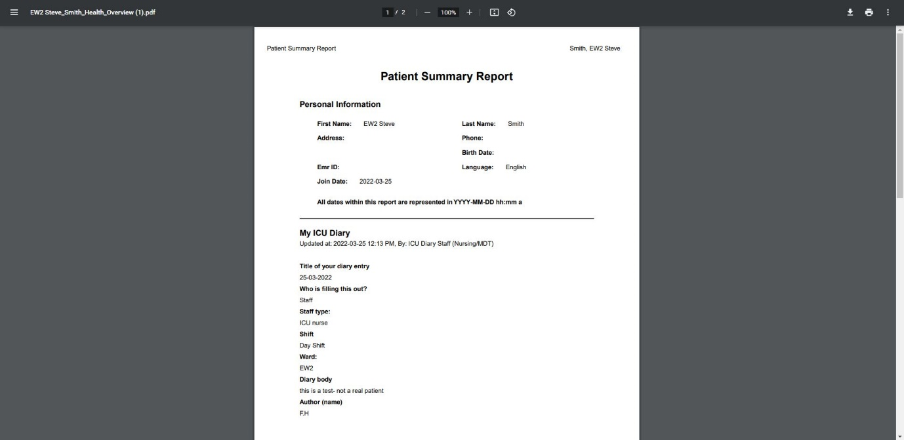

- This document will be saved on the desktop in the ‘downloads’ folder. Be sure to store this PDF document in an appropriate password protected folder only accessible to those staff involved in the return of the ICU e-dairy.

