ICU E- DIARY: CLINICAL STAFF GUIDE

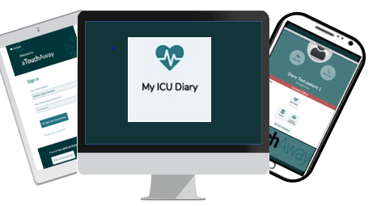

Life Lines has created a digital ICU patient diary using the aTouchAway™ application that can replace paper ICU diaries. The ICU diary also enables family members to make entries from home via their secure aTouchAway account on their own device (smartphone, tablet, or computer).
ICU patient diaries are designed to fill memory gaps and mitigate psychological distress. Diaries can positively impact psychological recovery of ICU survivors. They also help family members to process experiences.
Our ICU diary enables entries from any member of the ICU interprofessional team via bedside or desktop computers or tablets. The ICU diary can be downloaded by a member of the ICU team and then returned to the patient in a PDF format at a later date.
The ICU diary was launched at Guy’s and St Thomas’ NHS Foundation Trust in October 2021 and has received positive feedback from both family members and staff.
“The biggest benefit for me as a family relative using the ICU diary is that I can put my thoughts and feelings down on the ICU diary from home. It’s accessible and easy to use “Feedback from family member
“The ICU diary is advantageous as it is easy to access. It can’t get lost if the patient is transferred to a different unit” Feedback from ICU nurse
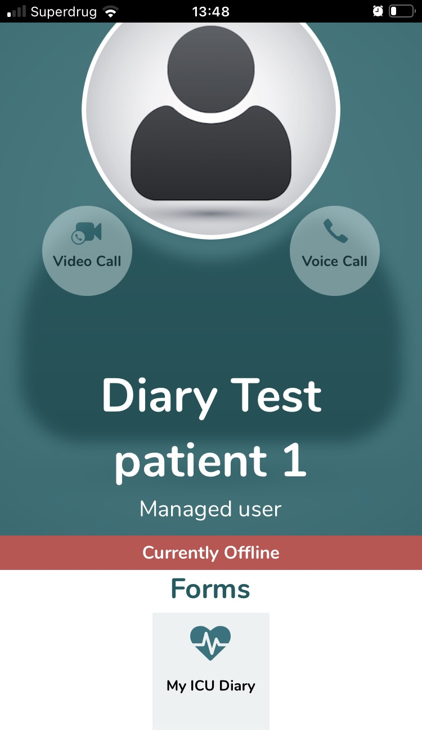

Advice for clinical staff on getting started with the ICU diary
This page provides the following guidance:
- Making a patient ICU diary profile
- Making ICU diary entries
- Linking family members to the patient’s ICU diary account and making them a care team member

STEP 1: Making a patient ICU diary profile
- Open the aTouchAway app on the ICU computer or tablet using Google chrome

- Log in to aTouchAway with the generic login & password chosen for the ICU
e.g. icudiarystaff@xxxx.icu and password xxxx&family1

NOTE: The ICU diary login and password is different from the virtual visiting login/password.

- Double check that the patient does not already have a profile set up for virtual visiting to avoid duplicate accounts. Find the patient by searching for the name of the ICU or the patient’s name e.g., EW2 or Steve Smith.

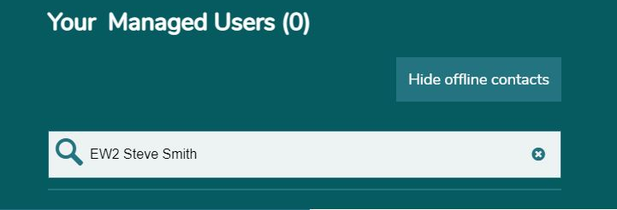

- If there is no patient profile, click on the ‘Creation & Token’ button on the bottom right-hand side of the screen to create a new patient profile.

- Click on ‘Create new user’ at the top of screen to bring up the ‘new user’ profile page.

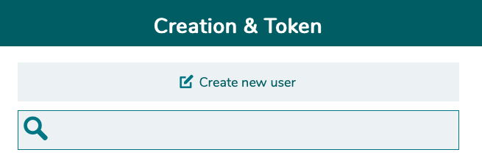

- Fill out the new profile with the patient’s details.

  - If there are multiple ICUs in the hospital, make sure that in the ‘First Name’ row, type the ICU name before the patient’s first name. This makes it easier to search for a patient in the app by narrowing the search to the right patient in the right unit, especially if there is more than one patient with the same name. i.e., First name: EW2 STEVE, Surname: SMITH.

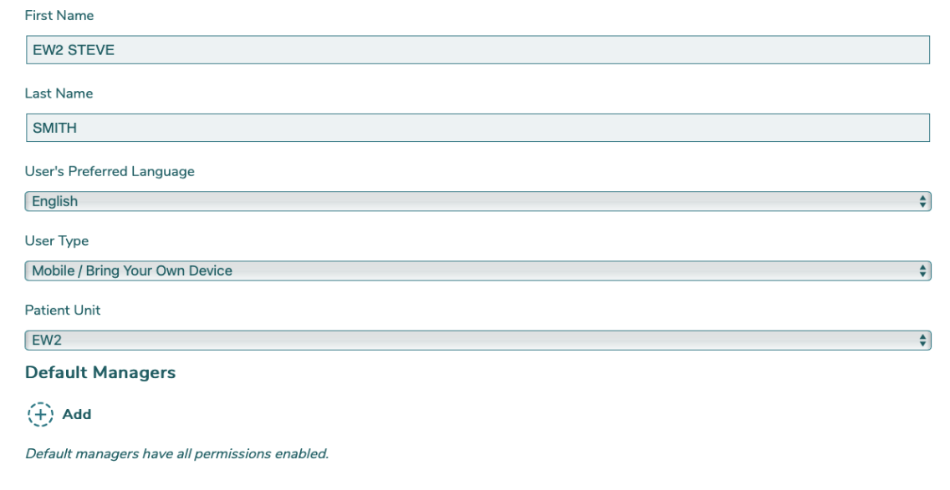

  - Keep the ‘User’s Preferred Language’ as English (as it will keep the app and content in the English language).

  - Keep the ‘User Type’ as ‘Mobile/Bring Your Own Device’ as this will keep the profile visible on other devices (tablets). Pick the correct ICU unit in ‘Patient Unit’.

- Before saving the new user make sure to click on the ‘+ Add’ symbol under ‘Default Managers’. Choose ‘ICU Diary Staff (Nursing/MDT)’ as the Default Manager to be able to create an ICU diary. Click on ‘Save’ button to finalise the action.

- Once save is pressed, go back to ‘Your Managed Users’ and type in the patient’s name and ICU. Click on the patient’s name to enter their home page profile as the image below

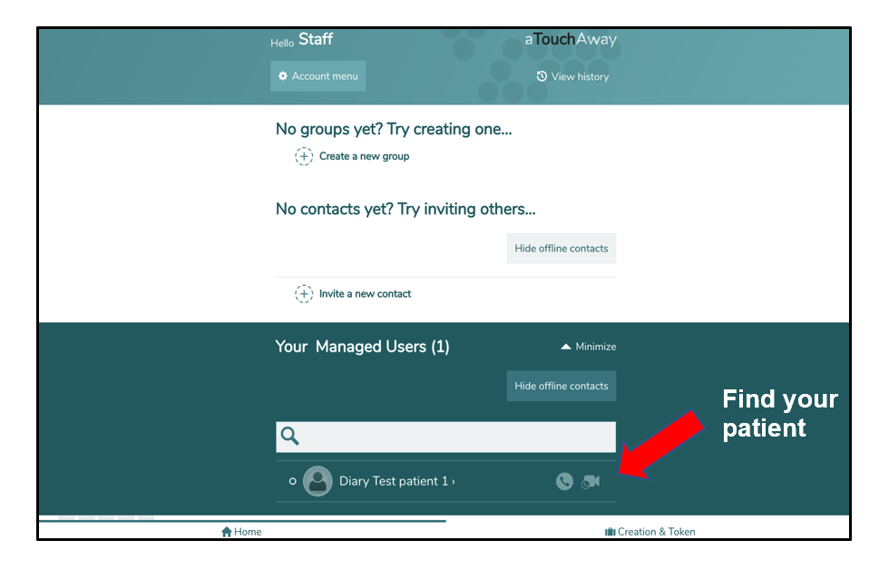

- The user profile should look like the picture below. If there is no ‘My ICU Diary’ in the Forms section, the ‘ICU Diary Staff (Nursing/MDT) account has not been added as the default manager.

In this case, restart another profile page and delete the old profile.
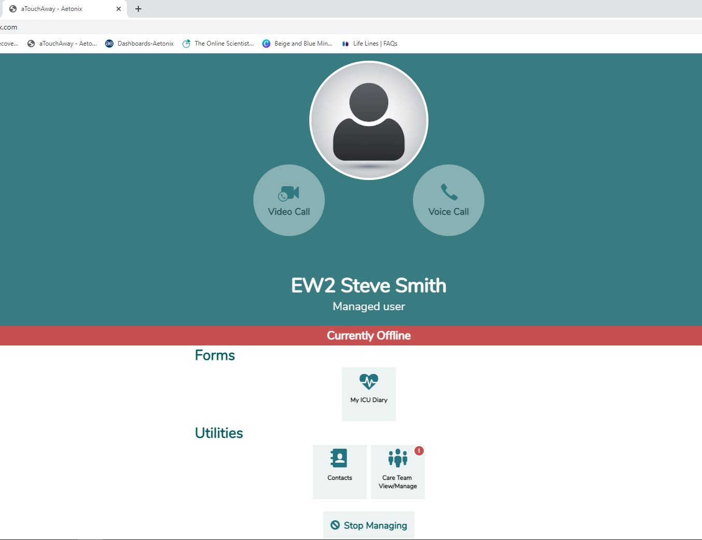

STEP 2: Making entries in the ICU diary
- Click on ‘My ICU Diary’ form to open the ICU diary form as shown below

- Start making an ICU diary entry on this form. Once finished, save your form.

NOTE: Read or download the example ICU diary guidelines and see example ICU diary entry content

- Once the diary entry is finished and saved, the form will appear as shown in the picture below.

- Any staff member can edit and review their own entry and entries from another clinical team member. Please do not delete entries. It is advised that your organisation identifies one or two staff members who are given permissions to edit entries if required – i.e., if incorrect information is added or inappropriate language is used.

- Family members will not be able to view staff entries in the ICU diary.

- This image is the screen seen when making an ICU diary entry.
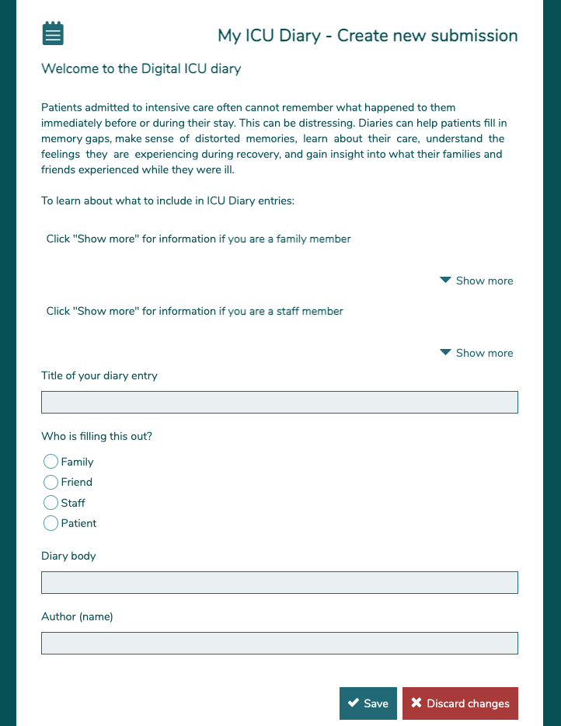

- This image is the screen seen when making an ICU diary entry.

Examples of clinical team entries
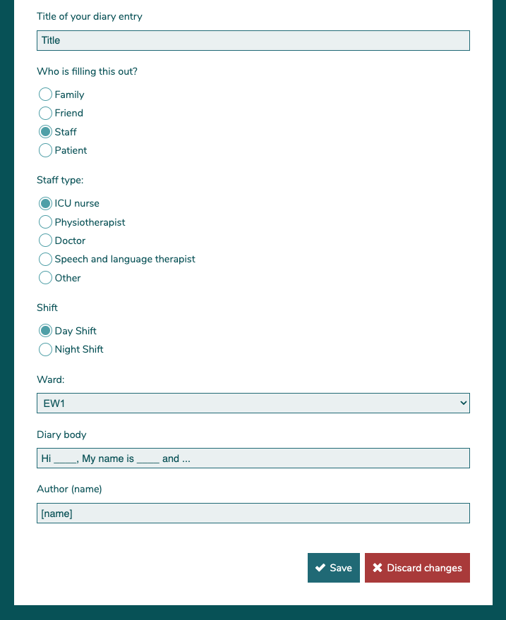

- This image shows how the ICU diary will appear on the app once saved.

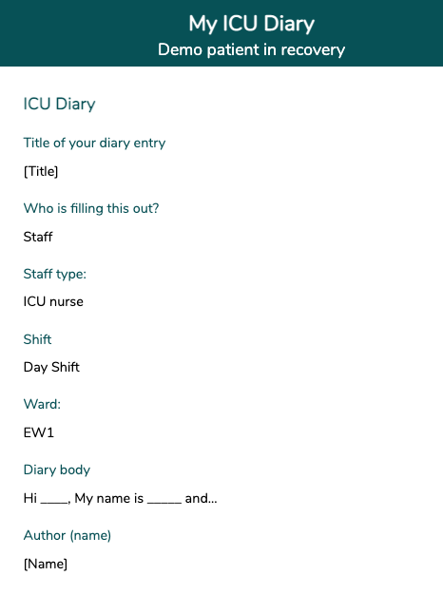

Examples of family member entries
- This image is the screen seen when a family member makes an ICU diary entry
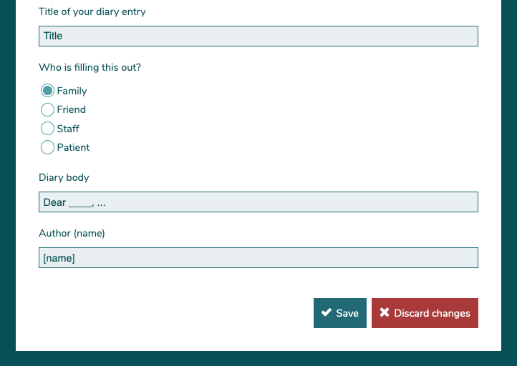

- This image shows how the ICU diary will appear on the app once saved.
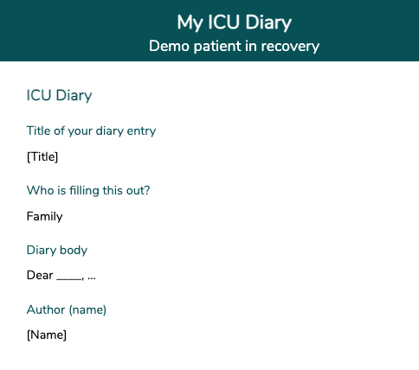

STEP 3: Linking family members to the patient’s ICU diary account and adding them as a care team member

- When the patient is selected the following image appears. This is the patient’s home page profile.

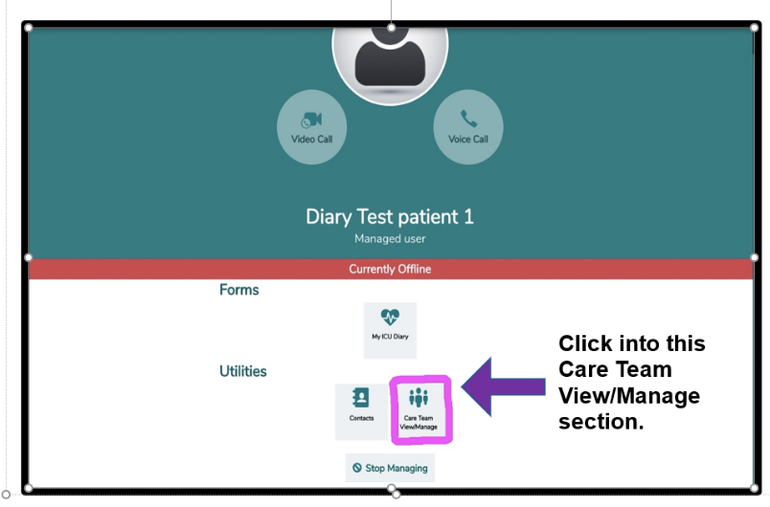

- Click on the ‘Care Team View/Manage’ box to grant the family member access to the ICU diary. This makes the family member part of the ‘Care Team’.
- The family member MUST be made a ‘Care Team Manager’ to gain access to the ICU diary.
- To invite a patient’s family or friend, click on ‘Invite a New Manager’.

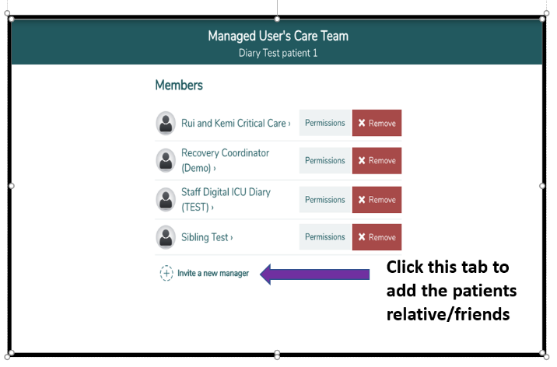

- The instruction for the next stage differs depending on whether the family member is already registered with aTouchAway for virtual visiting or a new user.

- To find out if they are already registered, type in the email address of the family member i.e., the email address used / or planning to use, to register on aTouchAway, in the ‘Search for a contact using their name or email and send them a request’ box.

- If the family member does not exist yet, the system will not identify the email contact and the words ‘Sorry, we can’t find anybody matching that search’ will appear.

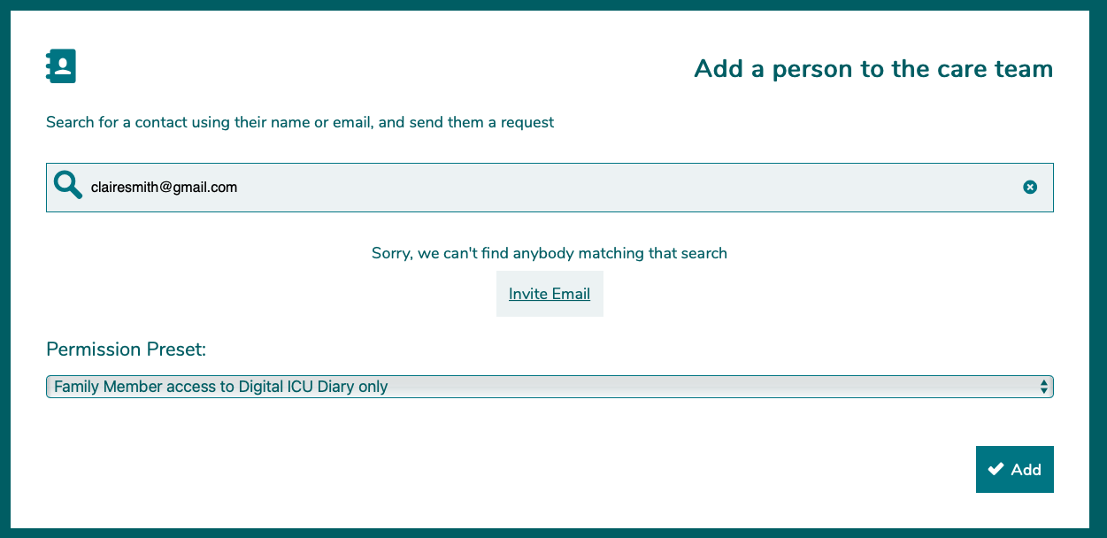

- Click on ‘Invite Email’, then select the language for the automated email and an automated email will be sent to the family members email account. The email invites the family member to ‘join the Aetonix social network’.

NOTE: For the family member to accept the invitation, they MUST download the aTouchAway app and create an account by clicking on the ‘registration link’ within the email. (More details on the family member steps are found in the family user guide)

- On the ‘Permission Present’, scroll the options and pick the ‘Family Member access to Digital ICU Diary only’ option.

NOTE: DO NOT choose the ‘NOK: ICU Recovery Diary and resources’ – this is a common mistake, but this option is for the patients on the ICU Recovery Pathway post discharge. Also, ignore custom options as this will change settings on the e-diary.

- Click on the green ‘Add’ button to add the family member to the patients ‘Managed User’s Care Team’. Once the family member log in’s they will be automatically assigned as a ‘managed user’ for their family member.

- If the family member is already signed up to aTouchAway, the family member’s account name will appear under ‘People to invite’.

Click on the name to select. In the ‘permission Preset’ box, select ‘Family Member access to Digital ICU Diary only’ option. Click on the green ‘Add’ button to add the family member to the patients ‘Managed User’s Care Team’. The family member will then be sent the ‘managed user request’ to accept or decline (More details on the family member steps are found in the family user guide)

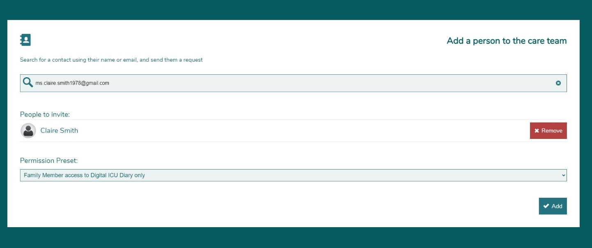

- Initially, family members sent a request to join will appear under ‘Pending requests’.

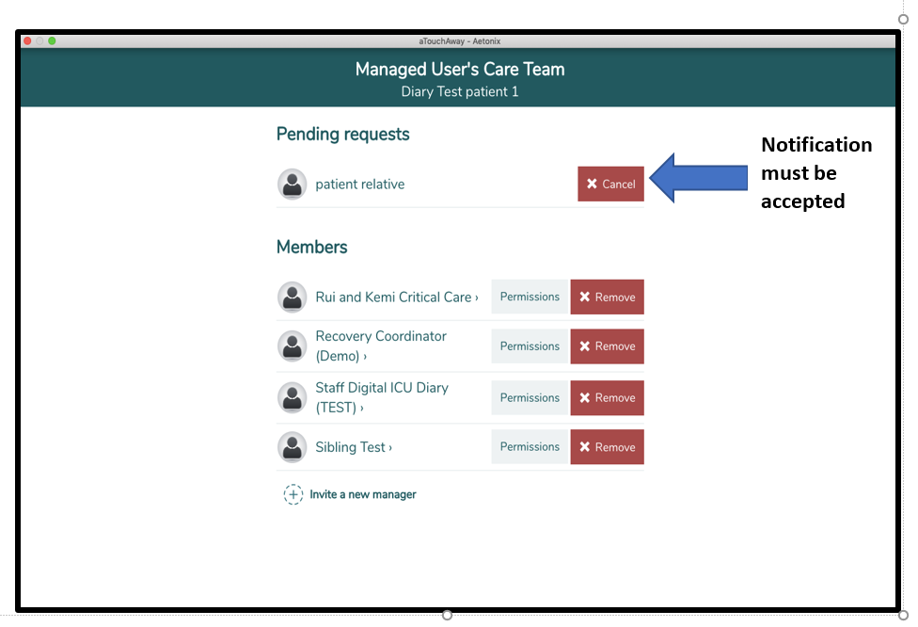

- Once the family member has accepted the ‘managed request’, the family member contact will be listed in the ‘Managed User’s Care Team’ page as displayed in the image below

