Guidance for staff on how to download a completed ICU e-diary from aTouchAway to PDF format
- Login to the Aetonix via the internet with this URL: https://app.aetonix.com . Bookmark this link as Aetonix works best using Google Chrome.

- Use the designated login name and password for the Aetonix website for the ICU e-diary aTouchAway account e.g., icudiaryadmin@xxxx.icu and xxxx&family2

Make sure this is set to the United Kingdom region. Only admin staff should log into the dashboard. This is not accessible to family members.

- The magnifying glass icon is the user search engine that allows users to find patients whose profiles are on the app. Click in the white search section using the patient’s name to find their profile. Once the patient’s profile appears, click on their ICU e-diary profile to open it up.

NOTE: If your patients name is not appearing, either their name has been misspelt or there has been no diary profile created for them. Be sure to check!

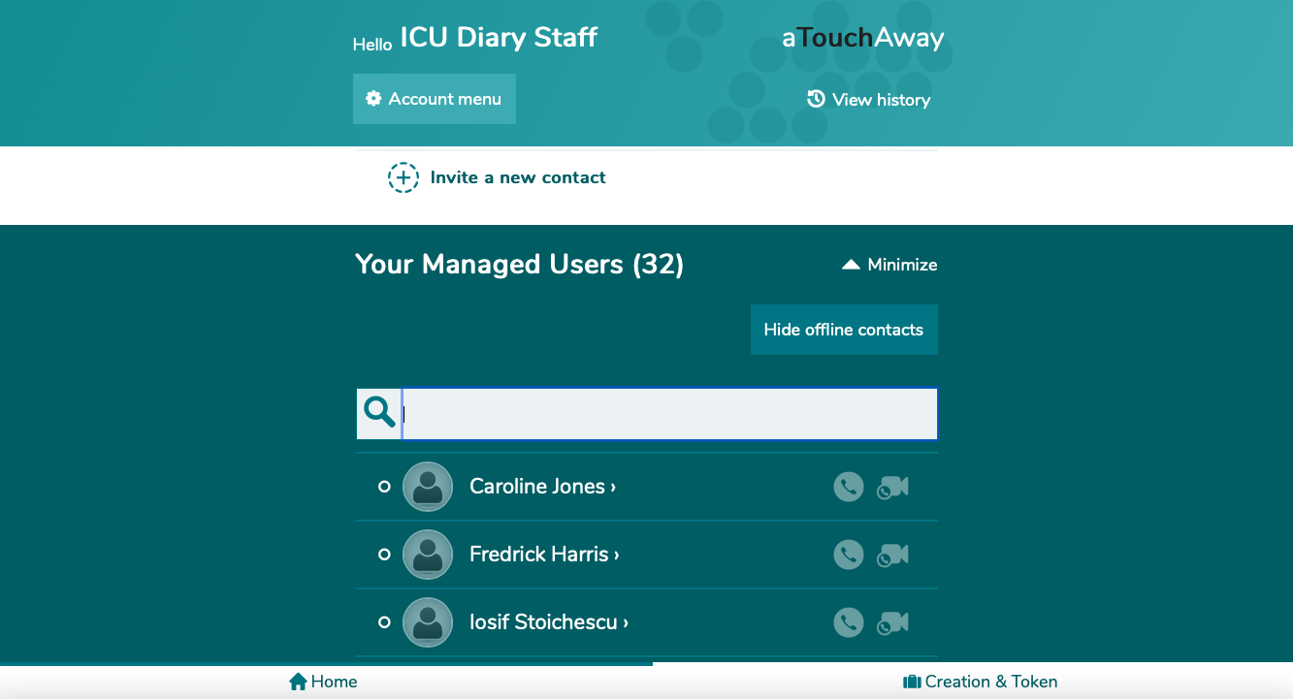
Search for your patient in this section.
Steve Smith
Steve Smith
Steve Smithe
Stephen Smith

- When you open the patient’s ICU e-diary profile, it should appear with several forms under the sections Forms and Utilities. The workflow form should also appear under the patient’s name. Click on the workflow folder.
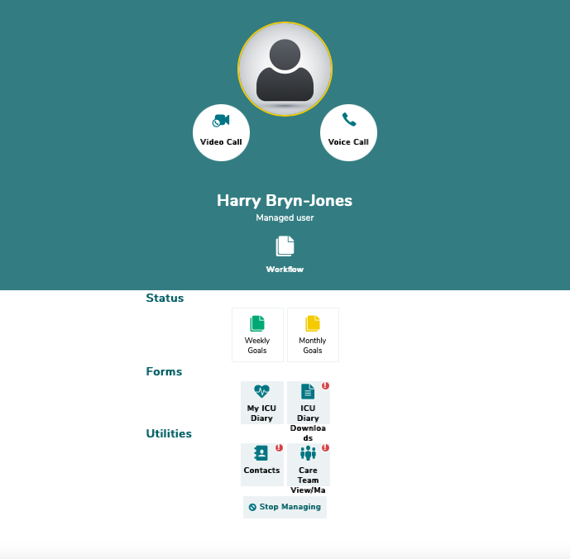
Steve Smith
Click on the workflow folder to download the ICU e-diary

- If the Workflow or ICU Diary Downloads forms are not present or visible, you must go on the Aetonix dashboards site to allow change permission settings on all patients’ profiles to make these forms visible. Go on the dashboards site URL https://dashboards.aetonix.com and login with the same login and password for ICU Diary Admin account.
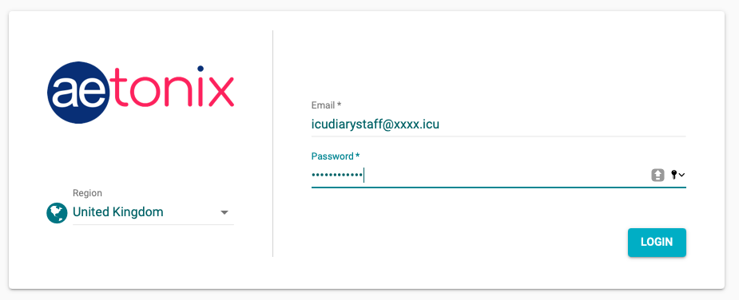
icudiaryadmin@xxxx.icu

- From the Dashboard homepage, click on MANAGERS under the ‘User Management’ section.
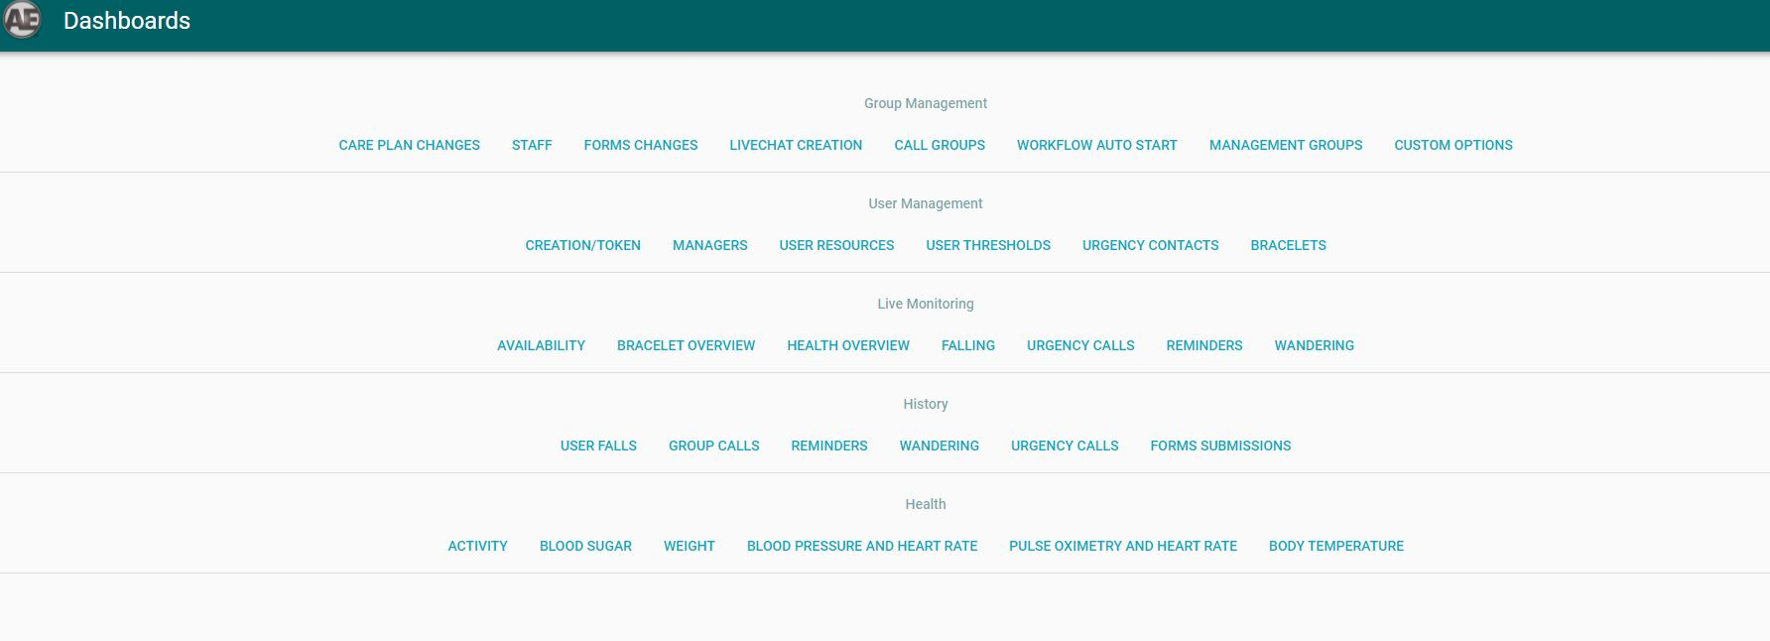

- In the MANAGERS section, there are two columns, Users and Managers that are presented side by side. Type the patient’s name in the ’Search Name or Client Number’ box in the ‘Users’ section. When the patient’s name appears, select the name by highlighting the patient.
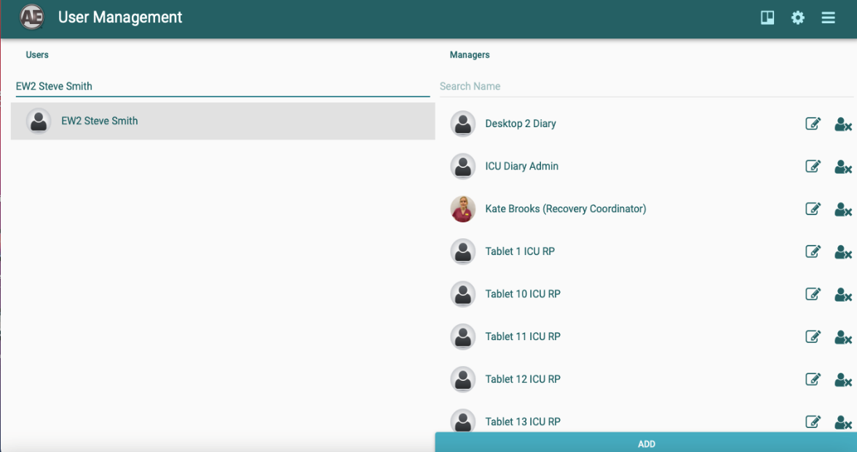

- Click on the permissions setting icon circled in red to bring up the Workflow and ICU e-diary Downloads forms. Setting a default permission will mean that the patients diary profile will appear with the necessary forms visible.

- Under the default permissions settings tab on the Aetonix Permissions, tick the box besides Workflow to ensure the workflows form will be visible. Scroll down to the bottom of the Form Permissions section to ICU Diary Downloads and change the option to Read/Propose change. One this is done, save these permission options to make these changes permanent.
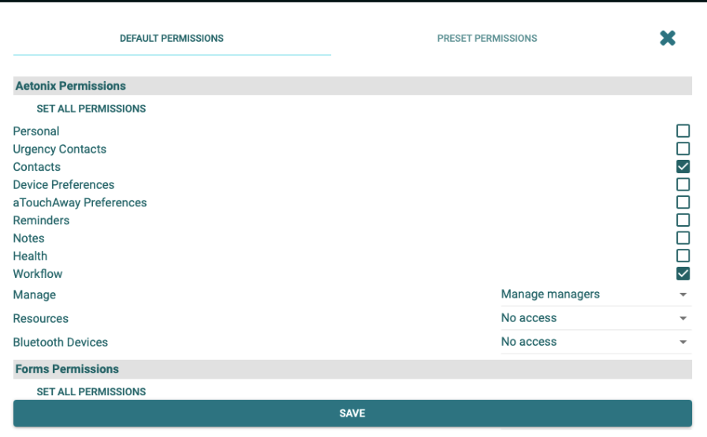
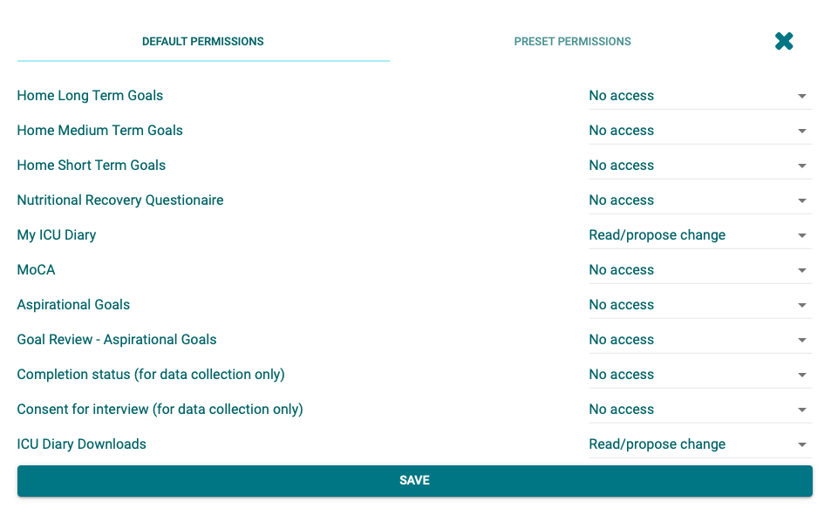

- Once those settings are saved, go back to the patient’s user profile on the ICU Diary website https://app.aetonix.com and the workflows and diary download forms should be visible.
Steve Smith
Click on the workflow folder to download diary

- On the workflow form, click on the following options to the dropdown toolbars to create the PDF download. Under the heading ‘Workflow Definition’, pick ICU Diary Downloads for that option. Be sure to label your diary PDF download under the ‘Workflow Label’ and Pick ICU Diary Admin as your option under ‘Clinician’. Once this form is complete, press the green SAVE button, to save the options.

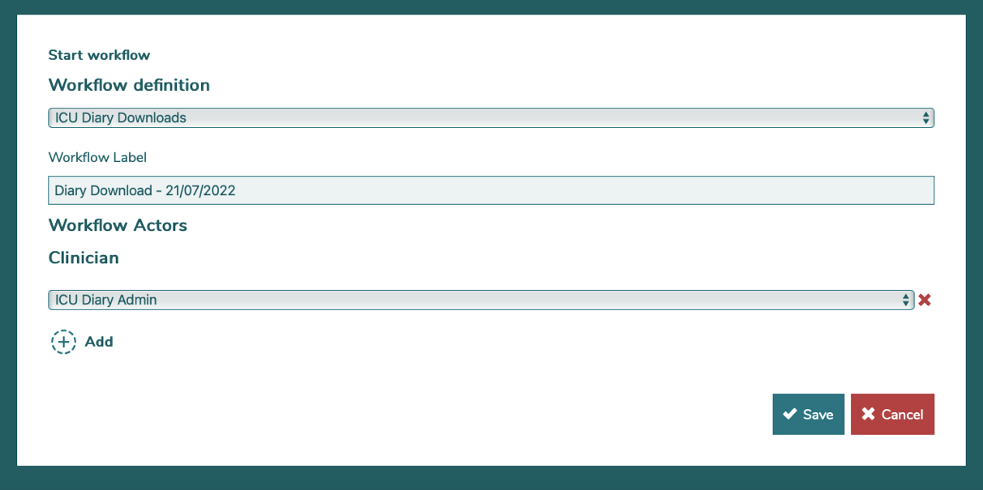

- Once you have saved the workflow, a pop-up box comment box will appear. You must leave a comment in the box; this could be any comment i.e Final Copy and click on the DONE button to save.

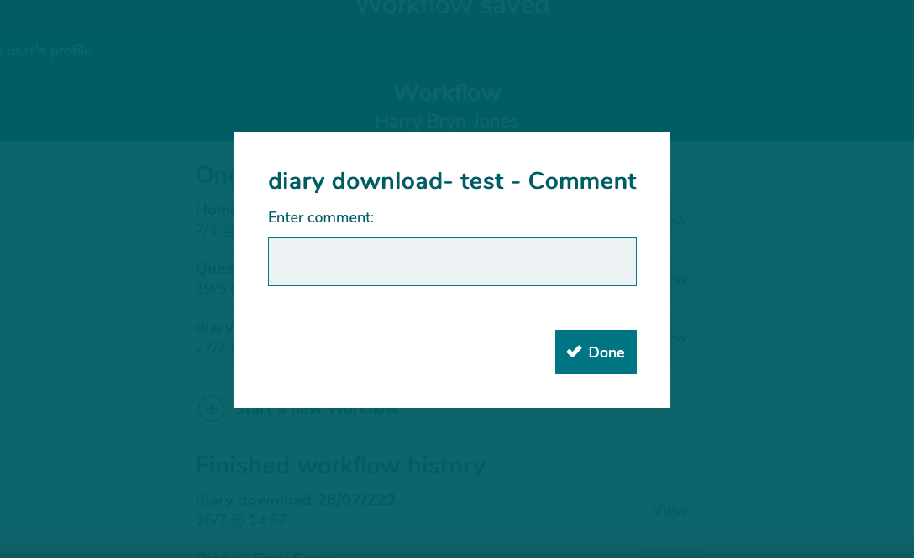

- Once the one button has be clicked on, the ICU e-Diary download will be generated which you will need to scroll and confirm as done. Scroll down to the bottom of the page click YES to indicate you are satisfied with the comments and click done.

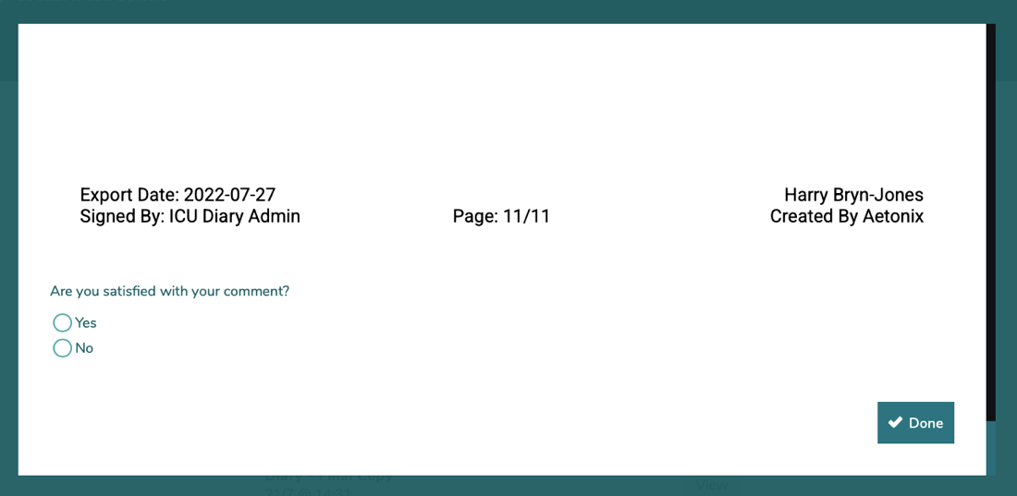

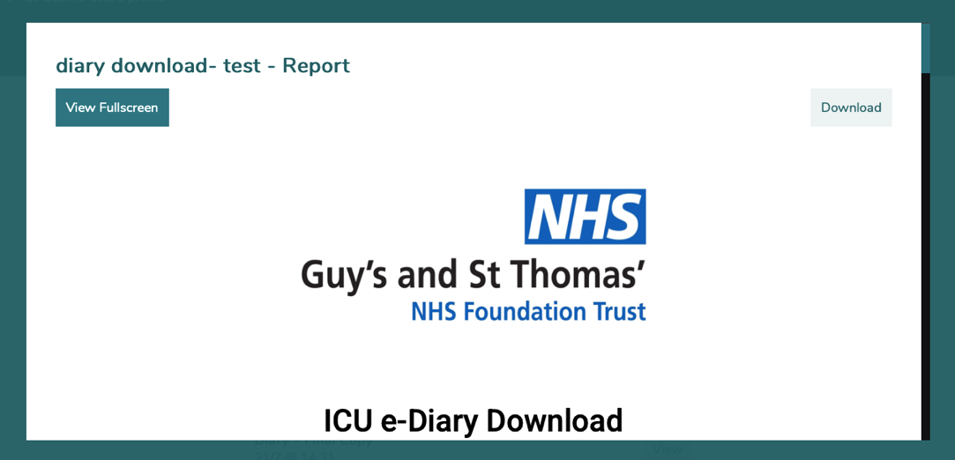
- Once this is done, the downloaded ICU e- diary should appear. Click on the DOWNLOAD button to download the ICU e-diary to your desktops download folder and re-name file to the patient’s name and hospital number. After this, move the PDF file to a password protected to store the ICU e-diary.

- Should you wish to do so, you can also download the ICU e-diary later from the ICU diary Download folder on the patient’s home profile. The ICU e-diary is stored in this section after the diary has been saved and can be printed from here also.
Steve Smith
You can also download the saved ICU e-diary from this folder.

